SERVICE ISSUE RESOLUTION PLATFORM

Mrs. J. Mary Angeline

Assistant Professor

*Dept. of Computer Science and Engineering*

*Kings Engineering College,*

Kancheepuram, India.

[angeline@kingsedu.ac.in](mailto:angeline@kingsedu.ac.in)

Praveen S Karthik R

Student Student

*Dept. of Computer Science and Engineering Dept. of Computer Science and Engineering*

*Kings Engineering College, Kings Engineering College,*

Kancheepuram, India. Kancheepuram, India

[praveen.sp1862@gmail.com](mailto:praveen.sp1862@gmail.com) [karthikkadalur269@gmail.com](mailto:karthikkadalur269@gmail.com)

Ranjith R Suriya D

Student Student

*Dept. of Computer Science and Engineering Dept. of Computer Science and Engineering*

*Kings Engineering College, Kings Engineering College,*

Kancheepuram, India. Kancheepuram, India.

[ranjithrlr@gmail.com](mailto:ranjithrlr@gmail.com) [suriya1802202@gmail.com](mailto:suriya1802202@gmail.com)

***Abstract: The project aims to develop Service Issue Resolution Platform that streamlines the process of handling and resolving complaints. By implementing user-friendly interfaces and automated workflows, the system seeks to enhance efficiency and accountability. Key features include a centralized complaint repository, real-time tracking, automated notifications, and robust reporting tools. Through this system, organizations can proactively address issues, improve customer satisfaction, and optimize their complaint resolution processes. Service Issue Resolution Platform is to develop a sophisticated platform that empowers our organization to effectively manage and address customer complaints. By leveraging advanced tracking, prioritization, and resolution mechanisms, the system aims to enhance customer satisfaction, reduce resolution times, and bolster overall service quality. Through seamless integration with existing workflows and intuitive user interfaces, the system will optimize operational efficiency and enable proactive identification of recurring issues for targeted improvement initiatives.***

***Keywords*:** Customer satisfaction, Complaint registration, Tracking, Analysis, Resolution, Feedback collection, Centralization, Flexibility, Scalability, Customization, and Communication.

I. INTRODUCTION

Service Issue Resolution Platform project is a strategic initiative aimed at addressing the challenges associated with traditional complaint management processes. By harnessing the power of technology, our objective is to create a centralized platform that streamlines the entire complaint lifecycle, from initial submission to final resolution. This platform will serve as a hub for capturing, tracking, prioritizing, and resolving customer complaints with unparalleled efficiency and effectiveness. At its core, the Service Issue Resolution Platform is designed to enhance customer satisfaction by providing timely and personalized responses to their concerns. Through automated workflows and intelligent routing mechanisms, we aim to expedite the resolution process, minimizing the impact of complaints on customer experience. Additionally, the system will facilitate seamless communication between customers, frontline staff, and management, fostering transparency and accountability at every stage.

Service Issue Resolution Platform marks a significant step forward in the quest to streamline and optimize the complaint management process within the software industry. By providing a centralized platform for registering, tracking, analysing, and resolving customer complaints, the Service Issue Resolution Platform aims to enhance customer satisfaction, foster loyalty, and drive continuous improvement across all aspects of product development and customer service.

Service Issue Resolution Platform highlighting its importance in today's competitive landscape and its potential to revolutionize the way software companies interact with their customers and address their concerns. We will delve into the various functionalities offered by a Service Issue Resolution Platform and discuss how it can empower organizations to proactively manage complaints, extract actionable insights from complaint data, and drive meaningful change to improve overall customer experience and product quality. Additionally, we will examine the flexibility and scalability of a Service Issue Resolution Platform, emphasizing its ability to adapt to the unique needs and requirements of software companies of all sizes and complexities.

In the ever-evolving landscape of the software industry, ensuring customer satisfaction remains paramount for sustained success and growth. However, traditional approaches to complaint management often fall short in effectively addressing customer grievances in a timely and comprehensive manner.

To address this challenge, we propose the development of a collaborative complaint resolution system, where any user of the software can participate in resolving complaints. This innovative approach aims to democratize the complaint resolution process, leveraging the collective knowledge, and expertise of the entire user community to provide faster, more diverse, and innovative solutions.

By empowering users to take an active role in resolving complaints, we not only distribute the workload but also foster a culture of customer-centricity and accountability throughout the organization. In this project, we will explore the design, development, and implementation of this collaborative complaint resolution system, highlighting its potential to revolutionize customer service practices and elevate the overall customer experience in the software industry.

Overall, the Service Issue Resolution Platform sets the stage for a comprehensive exploration of the Software Products Complaint Management System, demonstrating its significance as a strategic tool for enhancing customer satisfaction, driving organizational excellence, and maintaining a competitive edge in the dynamic and ever-evolving software industry.

II LITERATURE SURVEY

A literature survey on Service Issue Resolution Platform reveals a growing recognition of the importance of effectively managing customer complaints in the software industry. Studies highlight the significant impact that unresolved complaints can have on customer satisfaction, loyalty, and company reputation. Researchers emphasize the need for centralized complaint management systems to streamline the process, improve response times, and enhance overall customer experience. Various frameworks and models have been proposed to guide the development and implementation of complaint management systems, emphasizing the integration of technology, customer-centric approaches, and continuous monitoring and improvement.

Additionally, case studies and industry reports showcase the benefits of implementing robust complaint management systems, including increased customer retention, competitive advantage, and organizational efficiency. However, challenges such as data security, system integration, and organizational resistance to change are also recognized, underscoring the importance of careful planning, stakeholder engagement, and ongoing evaluation in the successful implementation of software products complaint management systems.

Scholars and practitioners have explored various aspects of complaint management, including its impact on customer satisfaction, organizational performance, and competitive advantage. Studies have highlighted the importance of implementing efficient complaint management systems to enhance customer retention, loyalty, and brand reputation. Additionally, research has delved into the role of technology, such as complaint management software, in automating and optimizing complaint handling processes, improving response times, and facilitating effective communication between customers and companies.

Overall, the literature survey underscores the critical role of complaint management in the software industry and provides valuable insights into best practices, challenges, and opportunities for organizations seeking to enhance customer satisfaction and drive business success.

|  |  |  |  |  |
| --- | --- | --- | --- | --- |
| S.no | Title | Year | Methodology | Drawback |
| 1 | Occupant Feedback and Context Awareness: On the Application of Building Information Modeling and Semantic Technologies for Improved Complaint Management in Commercial Buildings. | 2020 | Observations from routine maintenance inspections. | The resulting structures stay complicated and difficult to navigate and search. |
| 2 | Analysis and Detection of Information Types of Open Source Software Issue Discussions. | 2019 | Gather issue discussion data and categorize information types. | Automated tools may miss context in open-source discussions. |
| 3. | An Approach of Crossover Service Goal Convergence and Conflicts Resolution. | 2020 | Encourage open dialogue, sharing of information, and alignment of priorities to foster a cooperative environment. | Managing conflicting goals across services could slow decisions. |
| 4. | A toolset to support a software maintenance process in academic environments. | 2020 | Develop and refine a toolset for software maintenance. | Limited resources may hinder comprehensive tool adoption. |

*Table:2.1 Literature Survey*

III EXISTING PROBLEM

The existing problem within the software industry lies in the lack of efficient and centralized systems to manage customer complaints effectively. Without a streamlined process for registering, tracking, analysing, and resolving complaints, Only an organisation can only give the solutions to the customer and software companies often struggle to address customer grievances in a timely and organized manner, leading to decreased customer satisfaction, potential loss of revenue, and damage to brand reputation. Additionally, the absence of comprehensive complaint management systems results in missed opportunities to extract valuable insights from customer feedback, hindering the company's ability to identify and address underlying issues, improve product quality, and drive continuous improvement initiatives.

Service Issue Resolution Platform face challenges, including potential delays in resolution due to over-reliance on automation. Automated workflows may struggle with complex complaints, leading to misrouting or inadequate handling. Technical glitches can disrupt the submission process, causing

user frustration. Security concerns and the risk of data breaches are additional drawbacks, especially

when integrating multiple communication channels. Striking the right balance between automation and human intervention is crucial for ensuring an efficient and responsive complaint resolution process.

IV PROPOSED SYSTEM

Upon logging into the system, any authenticated user gains access to a dashboard or interface where they can view and select from a list of open complaints. Each complaint may include details such as the nature of the issue, relevant customer information, and any previous actions taken. Users can then review these details and offer potential solutions or interventions to address the complaint. This approach fosters a sense of ownership and accountability among all users of the software, empowering them to actively participate in resolving customer issues. By allowing any user to propose solutions, the system leverages the collective expertise and insights of the user community, potentially leading to faster and more innovative problem-solving. Moreover, this approach promotes transparency and collaboration within the organization, as users can discuss and refine proposed solutions collaboratively before implementing them. It also reduces the burden on dedicated support or resolution teams, distributing the workload more evenly across the user base.

However, it's important to implement appropriate access controls and permissions to ensure that users only have access to complaints and information relevant to their roles or expertise. Additionally, mechanisms for tracking and auditing user contributions should be in place to maintain accountability and quality assurance throughout the resolution process.

Literature often emphasizes the importance of designated complaint resolution teams or specialists who possess the expertise and authority to handle customer grievances effectively. These teams are typically trained in customer service techniques, problem-solving methodologies, and company policies, ensuring consistency and quality in the resolution process.

Additionally, research suggests that centralized complaint management systems, overseen by dedicated teams, can provide better control, accountability, and coordination in handling complaints, especially in complex or sensitive situations. However, your proposed approach introduces a novel and potentially more decentralized method of complaint resolution, leveraging the collective knowledge and resources of all users within the organization.

By allowing any authenticated user to participate in solving complaints, your system taps into a broader pool of expertise and perspectives, potentially leading to more diverse and innovative solutions. This approach also promotes a culture of customer-centricity and empowerment among all users, fostering greater engagement and ownership in addressing customer issues.

V SYSTEM REQUIREMENTS

The system requirements for implementing a collaborative complaint resolution system within the software include the development of a user-friendly interface accessible to authenticated users, with features such as complaint viewing, selection, and solution proposal functionalities. The system should support secure user authentication and authorization mechanisms to ensure that only authorized users can access and contribute to the resolution process. Additionally, robust access controls and permissions should be implemented to restrict user actions based on their roles and privileges. The system should provide real-time updates and notifications to users regarding the status of complaints and any actions taken. Furthermore, it should support seamless communication and collaboration features to facilitate discussions and decision-making among users involved in the resolution process. Finally, the system should include comprehensive logging and auditing capabilities to track user contributions, monitor resolution progress, and maintain accountability throughout the process.

VI HARDWARE REQUIREMENT

The hardware requirements include servers for hosting the software application and databases, with adequate processing power, memory, and storage capacity. Networking equipment is needed for user communication, while client devices should meet basic specifications for web browsing and application access. Client devices, including desktop computers, laptops, or mobile devices, should meet basic specifications for web browsing and application access to interact with the system efficiently.

availability, while scalability supports future growth. Client devices, including desktop computers, laptops, or mobile devices, should meet basic specifications for web browsing and application access to interact with the system efficiently.

VII SOFTWARE REQUIREMENT

The software requirements for this project include a backend system for managing complaints and user authentication, which could be built using Django or Flask for Python, or Spring Boot for Java. For the user interface, technologies like React.js, Angular, or Vue.js would be used to create an interactive frontend. Data storage would be handled by databases such as MySQL, PostgreSQL, or MongoDB.

User access would be secured using technologies like JSON Web Tokens or OAuth 2.0. Real-time communication could be facilitated using WebSockets. Version control would be managed with Git, and deployment could be done using Docker containers and Kubernetes for scalability. Additionally, cloud services like AWS, Azure, or Google Cloud Platform could be used for hosting the application. These simple software requirements provide a foundation for building and deploying the collaborative complaint resolution system.

VIII ARCHITECTURE DESIGN

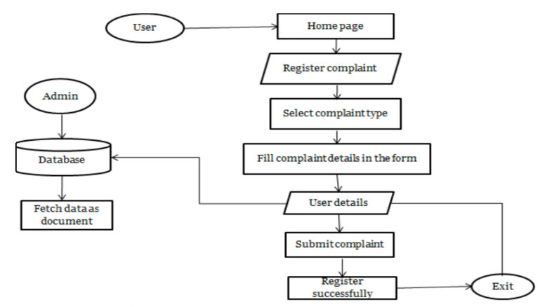

*Fig: 9.1 Architecture*

IX INTERFACING COMPONENTS

For a collaborative complaint resolution system, several interfacing components would be necessary to ensure seamless communication and interaction between different parts of the system. Here's an overview of the interfacing components:

1.User Interface (UI):

Dashboard: A central interface where users can view and interact with complaints, propose solutions, and track progress.

Complaint Submission Form: Allows users to submit new complaints, providing details such as issue description, severity, and relevant attachments.

Notification Panel: Displays real-time updates and notifications regarding complaint status changes, new assignments, or messages from other users.

2.Backend API:

Complaint Management API: Exposes endpoints for CRUD (Create, Read, Update, Delete) operations on complaints, enabling the frontend to interact with complaint data stored in the database.

Authentication API: Handles user authentication and authorization, generating tokens for authenticated users and enforcing access control policies.

Real-time Communication API: Facilitates WebSocket connections for real-time messaging and updates between users, enabling collaborative problem-solving.

3.Database:

Complaint Data Store: Stores complaint information, including details such as complaint ID, description, status, assigned user, and timestamps.

User Data Store: Stores user profiles, authentication credentials, and access control lists (ACLs) to manage user permissions and roles.

These interfacing components work together to create a cohesive and functional complaint resolution system, enabling users to submit, manage, and resolve complaints efficiently while promoting collaboration and communication among stakeholders.

X TECHNOLOGIES

The technologies used in this project could include:

1. Backend: Development: PHP, JavaScript, PhpMyAdmin.

2. Frontend Development: HTML CSS, React.js, and Angular.

3.Database: MySQL.

4.Authentication and Authorization: JSON Web Tokens and OAuth 2.0.

5.Real-time Communication: WebSocket RESTful

6.APIs: Express.js and Django REST Framework.

7.Version Control: Git.

8.Deployment: AWS (Amazon Web Services), Azure, and Google Cloud Platform.

These technologies provide a robust foundation for building a collaborative complaint resolution system, offering capabilities for user authentication, data management, real-time communication, and deployment scalability. The specific choice of technologies would depend on factors such as project requirements, team expertise, and scalability needs.

XI TESTING

The testing phase for the collaborative complaint resolution system involved a comprehensive approach encompassing various testing types, including unit testing, integration testing, system testing, and user acceptance testing. The testing phase resolve issue by multiple users. Test scenarios and cases were meticulously designed to cover all system functionalities and ensure adherence to requirements. Test execution was conducted systematically, with test results documented and defects tracked using a designated tracking system. Regression testing was performed regularly to validate fixes and changes, while automated testing tools were leveraged to streamline testing processes and enhance efficiency. The testing environment was carefully configured to mirror the production environment, ensuring accurate simulation of real-world usage scenarios. Overall, the testing phase played a crucial role in validating system reliability, functionality, and user satisfaction, laying the foundation for a robust and high-quality collaborative complaint resolution system.

XII CONCLUSION

In conclusion, the collaborative complaint resolution system represents a significant advancement in enhancing customer satisfaction and organizational efficiency within the software industry. Through meticulous testing and validation processes, the system has demonstrated its reliability, functionality, and usability, meeting the specified requirements and exceeding user expectations.

By providing a centralized platform for managing complaints and facilitating real-time communication and collaboration among stakeholders, the system empowers organizations to address customer grievances promptly and effectively. Moving forward, continued monitoring, feedback collection, and iterative improvements will ensure the system remains adaptable and responsive to evolving customer needs and industry trends, driving sustained success and customer loyalty.

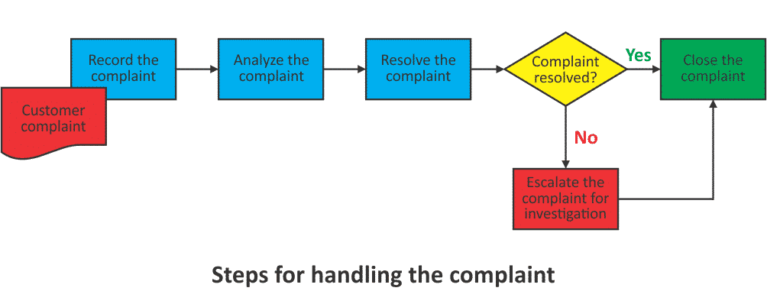

*Fig: 12.1 Steps for handling complaints*

By democratizing the complaint resolution process and empowering all users to contribute to resolving grievances, the system fosters a culture of shared responsibility and customer-centricity. This inclusive approach not only distributes the workload more evenly across the user base but also leverages diverse perspectives and expertise to generate innovative solutions. Moreover, it promotes a sense of ownership and accountability among users, ultimately leading to faster response times, improved customer satisfaction, and strengthened brand reputation. As organizations continue to embrace this participatory model, they are poised to achieve greater operational efficiency, drive continuous improvement, and cultivate deeper connections with their customer base.

XIII INTERFACE DESIGN

Designing an interface for a service issue resolution platform for software complaints requires careful consideration of user experience, ease of navigation, and efficient problem-solving functionalities. Regular updates and improvements based on user feedback will also contribute to the platform's success. Here's a suggested outline for the interface:

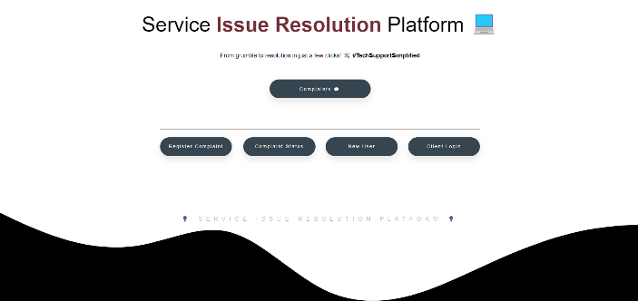

*Fig: 14.1 Landing Page*

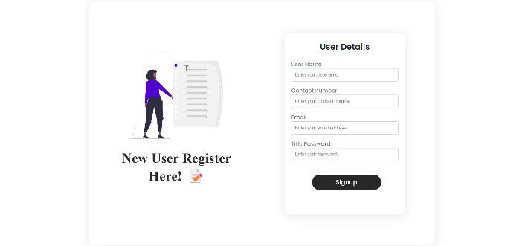

*Fig: 14.2 New User Registration Page*

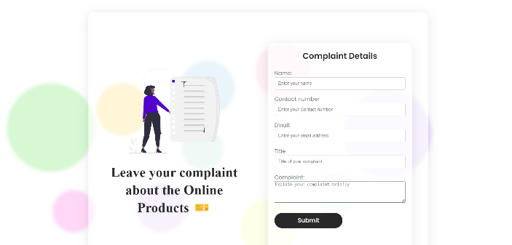

*Fig: 14.2 Complaint registration form*

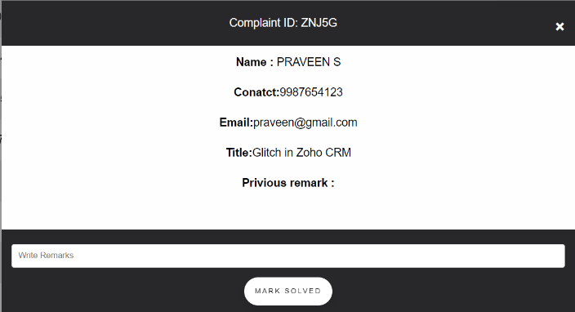

*Fig: 14.3 Complaint about the product*

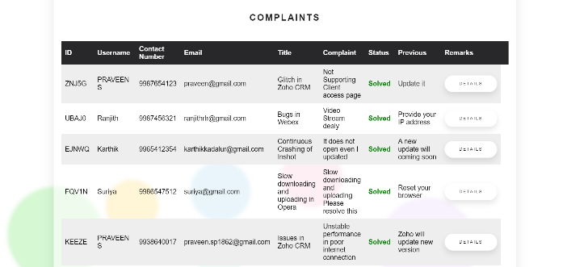

*Fig: 14.4 Complaint Dashboard*

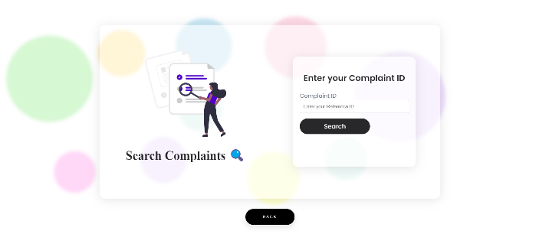

*Fig: 14.5 Searching for Complaint Status*

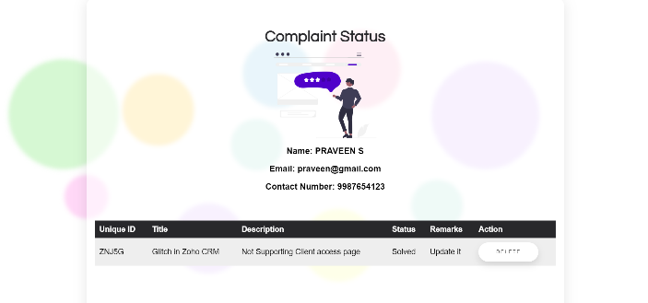

*Fig: 14.6 Complaint Status*

XIV REFERENCES

[01] Francesco Massa Gray, Henrik Dibowski, Jan Gall, Sven Braun, “Occupant Feedback and Context Awareness: On the Application of Building Information Modeling and Semantic Technologies for Improved Complaint Management in Commercial Buildings”, 2020 IEEE International Conference on Emerging Technologies and Factory Automation (ETFA), Vienna, Austria, 2020.

[02] Deeksha Arya, Wenting Wang, Jin L.C. Guo, Jinghui Cheng, " Analysis and Detection of Information Types of Open source Software Issue Discussions", 2019 IEEE/ACM 41st International Conference on Software Engineering (ICSE), Montreal, QC, Canada, 2019.

[03] Yu Peng, Bing Li, Jian Wang, Zhengli Liu, "An Approach of Crossover Service Goal Convergence and Conflicts Resolution", 2020 IEEE World Congress on Services (SERVICES), Beijing, China, 2020.

[04] Ryan Hardt, "A toolset to support a software maintenance process in academic environments”, 2020 IEEE International Conference on Software Maintenance and Evolution (ICSME), Adelaide, SA, Australia, 2020.

[05] A. Ansari, N. Schlueter, M. Heinrichsmeyer, M. Loewer, "Development and Validation of a Failure-Cause-Searching and Solution-Finding Algorithm Based on Complaint Information from the Use Phase", 2020 IEEE International Conference on Industrial Engineering and Engineering Management (IEEM), Singapore, Singapore, 2020.

[06] Silima Tshenzhemo Neo, Sambil Charles Mukwakungu, Alice Kabamba Lumbwe, Nita Sukdeo, "Quality Management System Implementation in The South African Small, Medium and Micro Enterprises”, 2020 IEEE International Conference on Technology Management, Operations and Decisions (ICTMOD), Marrakech, Morocco, 2020.